STATISTICAL ANALYSIS OF TEXT FILES

Yahya Asharf Mohamed 202000776

Communication and Information Engineering, Zewail City of Science and Technology

s-yahya.mohamed@zewailcity.edu.eg

**Abstract: It is required to create a GUI-based tool that allows a user to add any text file and results in some**

**statistics related to the text written in the file. The GUI can be built using Matlab App Designer or any**

**other software package..**

1. Introduction

Load cells are very common in weighing industry, its working principle relies on converting the mechanical force as pressure, compression, tension, torsion, etc. depending on the type of load cell to an analog electrical signal can be measured by a suitable measuring device. This signal usually has a very small amplitude, and some noise due to environmental factors and material imperfections. Thus, the output signal is first amplified and then filtered using a suitable filter to obtain a readable output at the end. The key here is the linear relationship between input (i.e. mechanical force), and output (i.e. reading) regardless of noise. This linear range enables us to find a relationship between the input and output. Thus, our main goal is to find the best linear relationship that minimizes the error as much as possible. This will be done by calibrating the load cell over the whole scale using know input (Egyptian coins), and then find a relationship between the input and the random error. The last phase is the designing of a simple embedded system that will first digitize the signal out of the filter, then modifies it based on the ML model, and finally output the signal on a quad 7-segment board using multiplexing technique. The load cell that will be used throughout the whole work is the strain gauge load cell shown in figure 1.

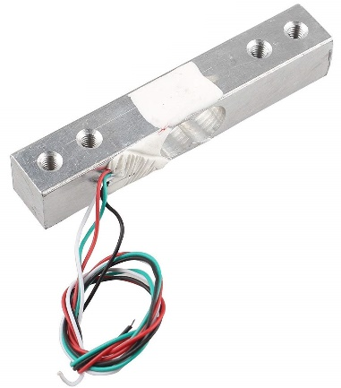

Figure 01: Strain Gauge Load Cell

1. Survey

The internal implementation of the strain gauge load cell is the same as the Wheatstone bridge circuit shown in figure 2.

When applying a force on one side and fixing the other side of the load cell as shown in figure 3, the length of the resistor on the upper face will increase while the length of the resistor on the lower base will decrease causing unbalanced Wheatstone bridge, so $V_{O}$ is no longer zero in this case.

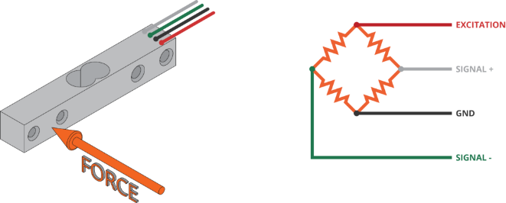

Figure 03: Applying force on a load cell

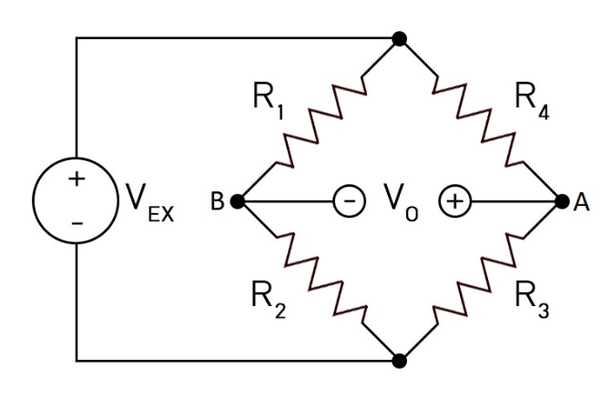

Figure 02: Wheatstone Bridge Circuit

By applying voltage divider law to node A:

$$\begin{aligned}V_{A}=V_{EX}\frac{R_{3}}{R_{3}+R_{4}}\#\left(1\right)\end{aligned}$$

By applying voltage divider law to node B:

$$\begin{aligned}V_{B}=V_{EX}\frac{R_{2}}{R_{1}+R_{2}}\#\left(2\right)\end{aligned}$$

$$\begin{aligned}∵V_{AB}=V_{A}-V_{B}=V_{O}\#\left(3\right)\end{aligned}$$

$$\begin{aligned}∴V_{O}=V_{EX}\frac{R_{3}}{R_{3}+R_{4}}-V_{EX}\frac{R_{2}}{R_{1}+R_{2}}\#\left(4\right)\end{aligned}$$

$$\begin{aligned}∴V_{O}=\left(\frac{R_{3}}{R_{3}+R_{4}}-\frac{R_{2}}{R_{1}+R_{2}}\right)V_{EX}\#\left(5\right)\end{aligned}$$

Based on the specifications of the load cell we are using:

The sensitivity is $1.0±0.1$ mV/V, the excitation voltage ranges from 5 to 10 V DC. This means that the maximum nominal value of the output would be 5 mV for 5 V input. This is a very small amount to be sensed by traditional voltmeters. Therefore, the analog discovery kit shown in figure 4 will be used to measure that small voltage.

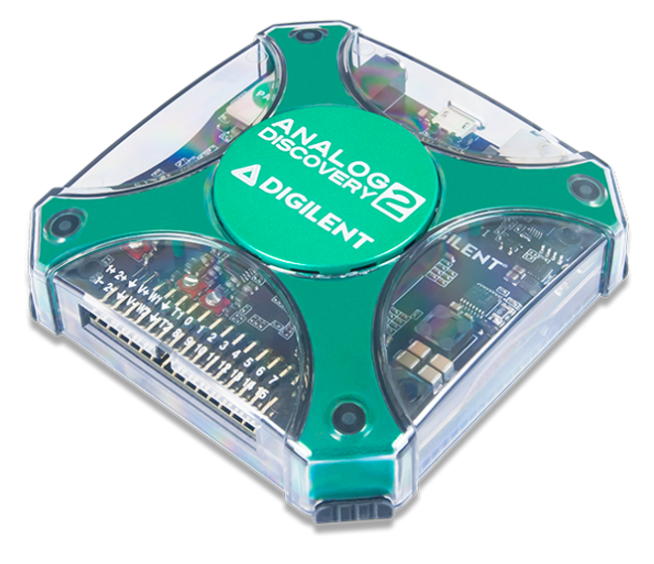

Figure 04: Analog Discovery 2 Kit

Also, this kit will be used as a power supply to supply the 5V excitation, and to obtain the output signal from the load cell. This signal will be analyzed later using LTspice.

Components expected to be used in t this project:

* Strain gauge load cell (1 kg)
* Egyptian coins (weights)
* 3d printed plates
* Breadboard
* Op-Amp
* Resistors
* Capacitors
* ATmega16
* USBASP AVR Programmer
* Quad 7-Segment
* Jumpers

1. Applications

A load cell is a type of transducer which is used to convert mechanical force into a measurable electrical output, anything which needs to be weighed probably uses a load cell to do so. Load cells come in many different shapes and sizes so that they can be added to different machinery and weighing equipment.

Types of load cells:

* Single point
* Shear beam
* Compression
* Pancake
* Bending beam load cells
* Dual shear beam
* Bending beam
* Miniature

What are load cells used for – more common applications?

1. Anything which requires weighing like:
   * Kitchen and bathroom scales
   * Self-service checkout
   * Weighing luggage at the airport
   * Pallet weighing
2. Industrial specific applications:
   * On-board weighing
   * Platform weighing
   * Belt scales
   * Overhead track scales
   * Hopper scales
   * Weighing agricultural produce
   * Medical equipment
   * Weighbridges

Bending Beam Load Cell:

Bending beam load cells are used in many different types of scales.

Bending beam load cells are extremely sturdy and reliable devices and therefore very suitable for use in harsh industrial environments.

Applications of Bending Beam Load Cell:

1. Dosing Scales:

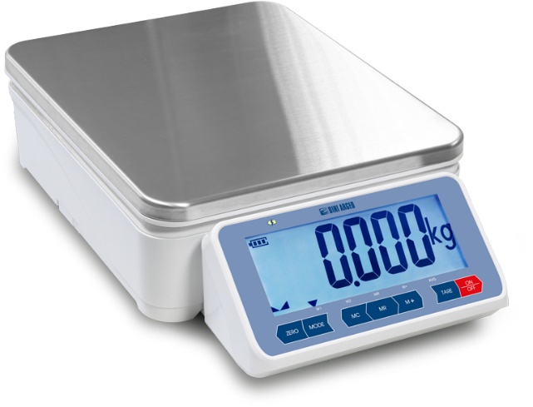

Figure 05: Dosing Scale

1. Overhead Conveyor Scales:

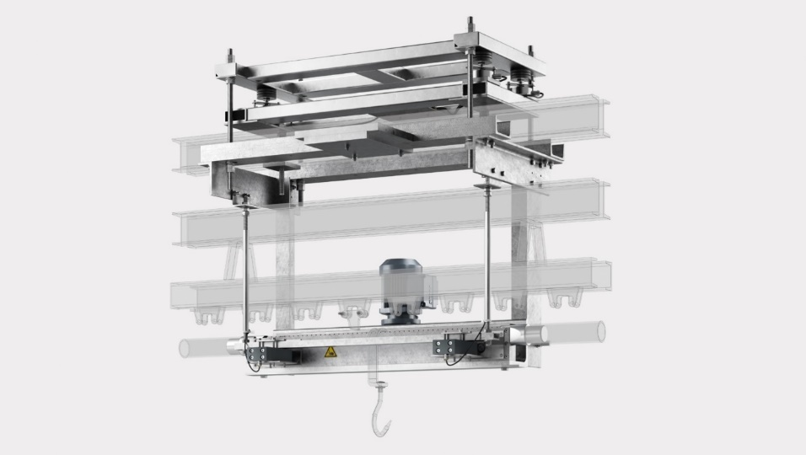

Figure 06: Overhead Conveyor Scale

1. Conveyor Scales:

A conveyor scale as shown in figure 7 allows products to be weighed in-motion, without having to be pulled off and weighed on a bench scale. This greatly reduces processing time for sorting, labeling, check weighing, and more.

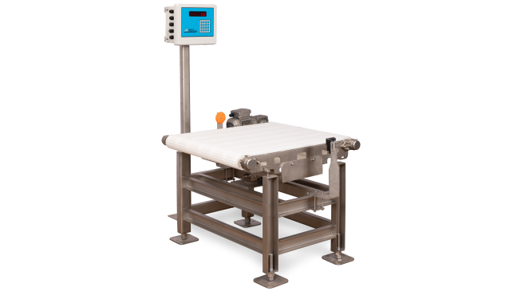

Figure 07: Conveyor Scale

Figure 10: Complete Function Block Diagram

Load Cell

Amplifier

Filter

I/P

O/P

6V

$r$ (t)

$a$ (t)

6V Battery

6V

ADC

$f$ (t)

Modification

$f$ (k)

DAC

$s$ (k)

Quad 7-Segment Display

$s$ (t)

5V (Voltage Regulator)

Microcontroller

1. Platform Scales:

A platform scale as shown in figure 8 is a weighing device that consists of one or two metal plates that hold items to be weighed and can have a smooth or diamond surface.

Note: - we normally find multiple bending beam load cells connected in parallel.

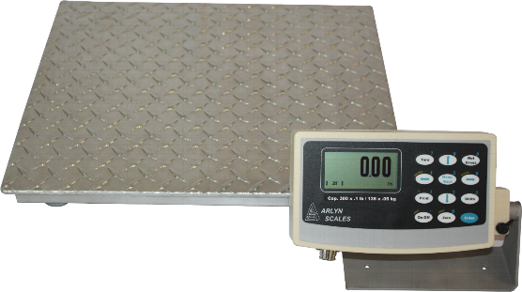

Figure 08: Platform Scale

1. Function Block Diagram

Simple block diagram:

Load Cell

Amplifier

Filter

I/P

O/P

Microcontroller

Figure 09: Simplified Function Block Diagram

Complete block diagram:

Explanation:

1. The system begins with the input in forms of weight by placing some coins on the upper plate of the scale.
2. Based on the input mass, the load cell will convert this force to electrical voltage $r\left(t\right)$ that can be measured using the analog discovery 2 kit giving that there is an excitation voltage of 5 to 10 V.
3. The electrical signal out of the load cell will then be amplified when this amplifier has the suitable power supply. The amplified signal will be $a\left(t\right).$
4. The amplified signal will be filtered to reduce the noise and obtain more accurate reading. The filtered signal will be $f\left(t\right).$
5. The filtered signal will be then passed to an ATmega16 microcontroller that will convert the analog signal into digital one $f\left(k\right)$.
6. The digital signal $f\left(k\right)$ will be modified based on the predefined ML model to improve the accuracy of readings. The modified signal will be $s\left(k\right)$.
7. The modified signal $s\left(k\right)$ will be converted into analog signal $s\left(t\right)$ that will determine which segments of the quad 7-segment board will work and which will not.
8. Finally, the output is displayed on the quad 7-segment board in grams unit.